**RECIPE APP USER MANUAL**

Table of Contents

**Page Navigation2**

Add Recipe Page3

Recipe List Page5

**NOTE!!!: FOR THE APP TO WORK PLEASE INSTALL NEWTOWNSOFT.JSON IN VISUAL STUDIO. GO TO PROJECT > MANAGE NUGET PACKAGES>BROWSE AND THEN SEARCH FOR AND INSTALL NEWTOWNSOFT.JSON AND NEWTOWNSOFT.JSON.BSON**

**PAGE NAVIGATION**

Upon opening the app you will be greeted with the Home menu page. This page is just for aesthetic purposes but it there is a visible close application button on the top right side that appears on all pages.

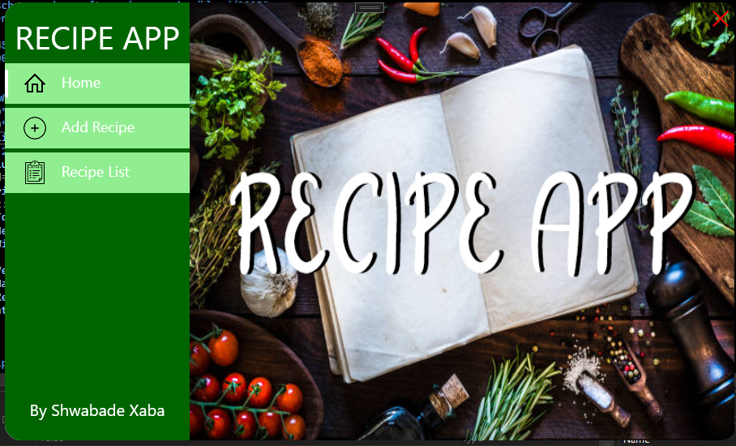

There are three tabs, **HOME, ADD RECIPE** and **RECIPELIST.**

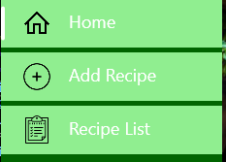

Home takes you back to the Home page and that is it’s only function. **CLICK ADD RECIPE TO GET STARTED!**

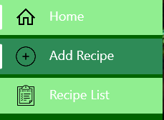

**ADD RECIPE PAGE**

Upon moving to this page you will see a page that has a textbox for the Recipe Title. **You Can Write The Name Of Your Recipe In this Box.**

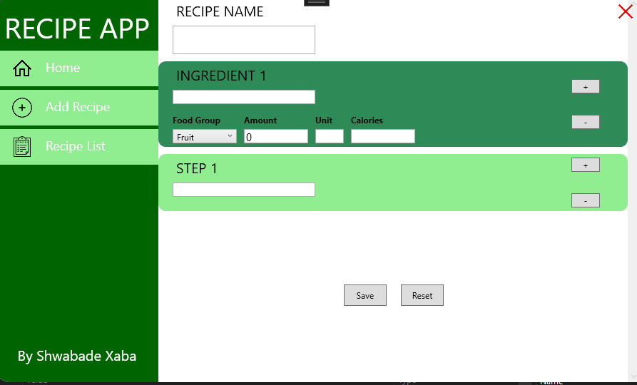

Underneath is a data template that allows the user to type in the data of a single ingredient and select the food group using the combo box.

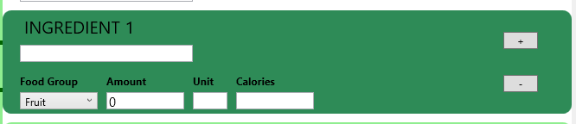

Type in the of one of your ingredients in the ingredients box then select which FoodGroup is the ingredient part of. Then type in the amount of said ingredient that you need followed by the ingredients unit of measurement e.g. KG,l, grams and then add the number of Calories.

There are two buttons on the side.

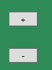

The **+** button adds a copy of the ingredient box whilst the **–** button removes a single copy or all copies until on the base template is left.

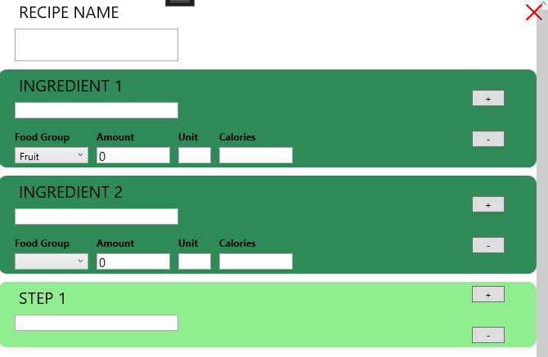

The step template also does the same thing except each new template is a line for you steps.

Below are two buttons. **SAVE** and **RESET**, the save button saves all the data on the present page to a JSON file in a folder within the project.

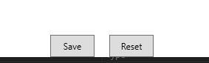

The reset button resets all the GUI elements and the text boxes so that the user can create a brand-new Recipe.

**PLEASE NOTE THAT A MENU WILL NOTIFY YOU IF YOUR RECIPE’S CALORIES EXCEED 300**

**RECIPE LIST PAGE**

The recipe list page displays a data grid with a search bar that displays all the files we created in our add Recipe page. It arranges our data from Recipe Name, Calories, FoodGroup and the date it was created and the date the file was modified.

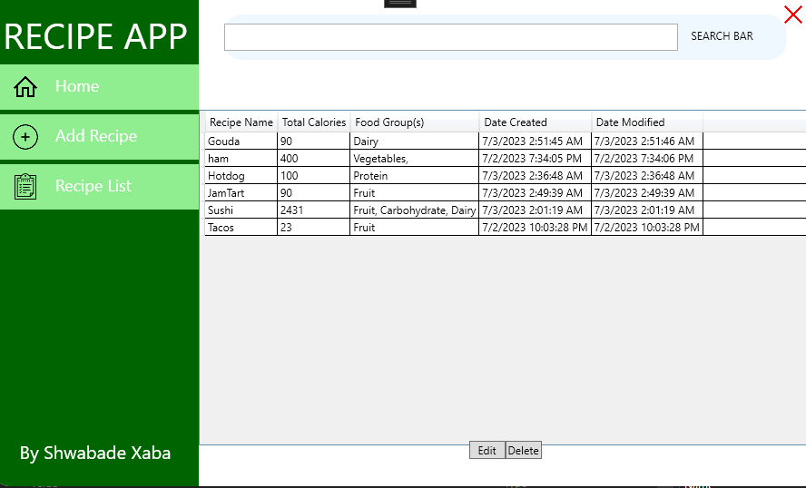

Our search bar allows us to filter the data to show use a recipe by its name, foodGroup or the maximum calorie a user may enter.

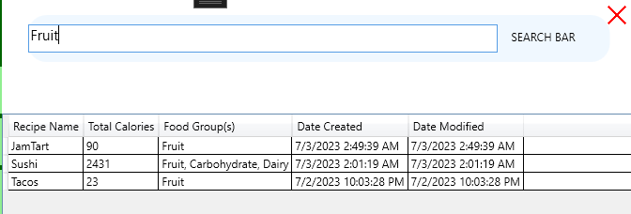

Double clicking a Recipe will display a message box that will show the contents of the recipe for the users own use.

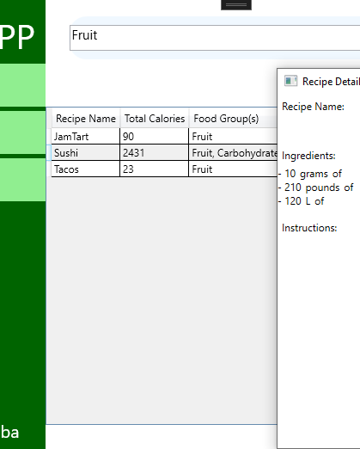

At the bottom are two buttons. **EDIT** and **DELETE.** The Edit Button edits the contents of the recipe the user selects. The delete button removes the JSON file of the selected recipe from the folder.

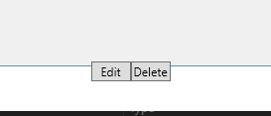

And once you’re all set, just hit the big red **X** on the side to exit the application.



**I hope you enjoy the app and may it serve you well! Cheers!**